Case Study: Biochemical, Hormonal, and Lifestyle Contributors to Maria’s Metabolic Imbalance
College of Engineering, Environment, and Sciences, Coventry University
5018BIO: Healthy Human Physiology
Dr Isadora Clivatti Furigo
26 November, 2025

Introduction
Out of approximately 13 million women who are currently menopausal or peri-menopausal in the UK (NHS, 2022), 75% of them experience menopause symptoms, while one-fourth of them go through severe menopause symptoms. (Wellbeing of Women, 2025) Menopause symptoms include vasomotor symptoms, sleep disturbances, and dryness of the vaginal wall, with increased risks of cardiovascular diseases and metabolic syndrome. These physiologic and metabolic changes are directly associated with oestrogen deficiency, which is the main characteristic of menopause. (Opoku et al., 2023)
These postmenopausal changes can affect energy balance and appetite regulation while interacting with family history and lifestyle, which is critical to understanding Maria’s Case in metabolic imbalances.
This case study highlights concepts of energy balance, hedonic and homeostatic eating, and hormones interfering with energy regulation. Also suggesting health interventions prioritising lifestyle-based strategies, this report aims to give an integrated understanding of the hormonal, physiological, and metabolic factors contributing to the condition.

Case Presentation

Maria is a 62-year-old female who went through menopause and also has a strong family history of type 2 diabetes mellitus and cardiovascular diseases. She suffers from fatigue, low motivation, and dissatisfaction with her body shape due to constant weight gain over the last decade. She had several attempts to lose weight via restrictive diets, which did not show any particular improvement, as she had difficulty maintaining a restrictive lifestyle and ‘emotional’ eating.

Table 1
Maria’s Body Composition
Weight | 91.5kg (201 lbs)
Height | 160cm (5.3 ft)
Total fat mass percent | 43%
Total lean body mass | 52kg
Activity factor | 1.2

Table 1 shows Maria’s body composition including the activity factor. From this information, calculations of BMI and BMR were conducted.
The Body Mass Index (BMI) is used as an indirect measure of obesity, as a high level of BMI indicates high excess body mass, which is caused by body fat. (Hakeem et al., 2024) Maria’s BMI was calculated by following Equation (1):
$$BMI=\frac{Body weight \left(kg\right)}{{\left[Height \left(m\right)\right]}^{2}} \left(1\right)$$
From this equation, Maria’s BMI is calculated: 91.5/2.56=35.742…$≈$35.7 kg/㎡(rounded to two decimal places)
The Basal Metabolic Rate (BMR) is an important measure of one’s energy expenditure, accounting for up to 60% of total energy, and measures the amount of energy required for vital activities of the body. (Popson et al., 2023)

Figure 1
Maria’s Basal Metabolic Rate (BMR) Calculation
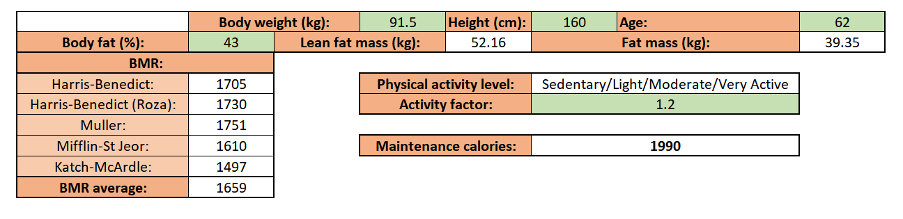

Figure 1 represents the BMR estimation of Maria from the average of the Harris-Benedict and other equations: 1,659kcal/day.
To look at the underlying hormonal and metabolic imbalance, a biochemistry test was conducted.

Table 2
Maria’s Biochemical Test Results
Analytes | Maria’s Results | Reference Range
Progesterone | 0.2 ng/ml | 0.1-0.8 ng/ml (postmenopausal)
FSH | 75 IU/L | 25-135 IU/L (postmenopausal)
LH | 42 IU/L | 15-62 IU/L (postmenopausal)
Total Testosterone | 28 ng/dl | 15-70 ng/dl (female)
Fasting glucose | 7.4 mmol/L | 4.0-5.5 mmol/L
HbA1C | 8.3% | 4.0-5.6%
Fasting Insulin | 37 mlU/L | 2.0-20 mlU/L
Fasting GLP-1 | 2.6 pmol/L | 2.3-4.3 pmol/L
Fasting Leptin | 44 ng/ml | 0.3-13.4 ng/ml
Fasting active Ghrelin | 16 pg/ml | 50-70 pg/ml
Oestradiol (E2) | 18 pg/ml | 20-150 pg/ml (postmenopausal: <30 pg/ml common)

From Table 2, it can be summarised that some of Maria’s analytes (fasting glucose, HbA1c, fasting insulin, fasting leptin) are out of reference range therefore causing metabolic imbalances.

Discussion
Biochemical markers (refer to Table 2) indicate that metabolic rather than reproductive hormonal pathways drive Maria’s symptoms. Therefore, it can be concluded that the case is mainly because of appetite-regulating hormonal and metabolic imbalance, rather than reproductive hormones.
Focusing on hormones and biochemical markers that are out of range, first, fasting glucose, which is regulated by insulin and glucagon, plays an important role in human physiology as it is a main fuel for the body. The elevated level of fasting glucose indicates type 1 and 2 diabetes mellitus, which can lead to the damage, malfunction, or failure of various organs. These complications are not only affecting a single part of the body but rather whole systems: cardiovascular, renal, and gastrointestinal. (Zhang et al., 2019)
To determine the individual’s glucose control levels, HbA1c (Haemoglobin A1c, also known as glycosylated haemoglobin) is tested, which measures the average blood sugar level of the past 90 days. (Eyth et al., 2025) Formation of HbA1c is accelerated when the average amount of glucose increases in the plasma. This is the reason why the raised level of HbA1c can be a risk factor for type 2 diabetes mellitus. (Sherwani et al., 2016) It was also confirmed that the elevated level of HbA1c can be a risk factor for coronary heart disease and stroke in diabetes mellitus patients. (Martín-Timón et al., 2014)
Thirdly, fasting insulin is a widely used measure of insulin resistance, which is a defective response to insulin stimulation. Type 2 diabetes mellitus is considered a dominant consequence of insulin resistance. (Freeman et al., 2023) The fasting insulin level is also an important marker to determine the type of diabetes mellitus, as subjects with type 1 diabetes mellitus cannot secrete insulin because of the destruction of insulin-producing β cells therefore leading to insulin deficiency.
Leptin is a peptide hormone that regulates appetite, energy homeostasis, and neuroendocrine functions while also impacting the immune system and metabolism of the body, precisely taking a role in lowering energy intake. (Dornbush and Aeddula, 2023) The study conducted by Askari et al. (2010) shows that fasting leptin level is directly correlated with adipose, fasting glucose levels, and insulin resistance. Therefore, like the fasting insulin level of Maria, this also indicates that the insulin resistance of Maria is significantly higher than it should be, which leads to hyperinsulinemia.
Lastly, fasting active ghrelin level was remarkably lower than it should be. Unlike leptin, which promotes a feeling of satiety, ghrelin increases appetite and induces food intake. (Aoun and Schmidt, 2019) As proved by Papandreou et al. in 2017, fasting ghrelin levels are significantly lower in obese subjects and it also affects insulin resistance.
During fasting, ghrelin increases to stimulate appetite, whilst insulin, GLP-1 and leptin fall. (Fink et al., 2024) Following food intake, insulin and GLP-1 rise to promote glucose uptake and satiety, while ghrelin is suppressed. In Maria’s case, elevated fasting insulin together with low ghrelin suggests impaired metabolic flexibility, consistent with insulin resistance in obesity.
To maintain ideal body weight for an individual, energy expenditure should be the same as energy intake. This state is known as energy balance, and it is based on the fundamental thermodynamic law that energy can only be gained, stored, or used. (Hill et al., 2013) Disturbance in this energy balance causes one’s body mass to change, either decrease or increase. Meanwhile, the energy intake equals the calories of the food eaten, and food intake is regulated by homeostatic signals and hedonic cues.

Figure 3
Food Intake Cycle in Homeostatic Regulation
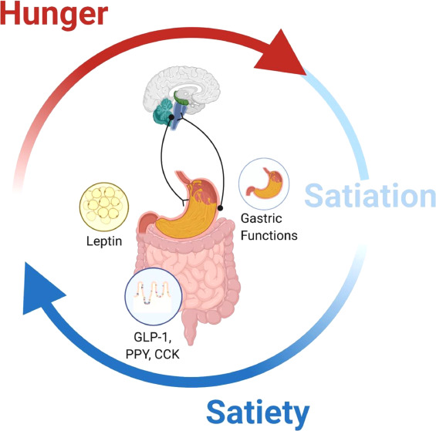
From Cifuentes and Acosta (2022)

As shown in Figure 3, the integration of hormonal, metabolic, and neuronal signals regulates homeostatic eating, and this is due to the feeling of satiety fading and hunger increasing when the fasting state is prolonged. (Cifuentes and Acosta, 2022) Hedonic eating, on the other hand, is not driven by the physiological need for nutrients without physical hunger. (Espel-Huynh et al., 2018) But it is rather from one’s desire to consume the food for pleasure, which in Maria’s case is called “emotional eating.”
Based on anthropometric data of Maria (BMI of 35.7 kg/m²) and Figure 4, which presents the classification of BMI, Maria is considered obese, precisely obesity class 2. As stated by Berthoud et al. (2017), obesity can be caused by hedonic overeating.

Figure 4
Classification of BMI
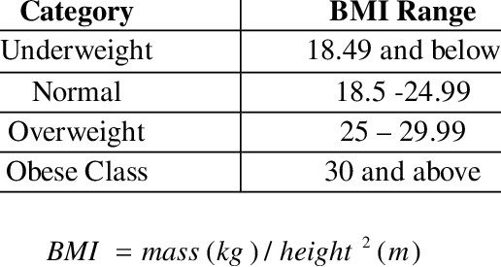
From Abana et al. (2020)

Moreover, her biochemistry result provides clear clues of critical metabolic dysfunction. Hb1AC of 8.3%, 37 mlU/L of fasting insulin, and other analytes (Table 3) also indicate high insulin resistance, leading to Type 2 diabetes mellitus. The estimated risk for type 2 diabetes mellitus increases approximately by 2-4 times when one of the parents or both have the condition. (Papazafiropoulou et al., 2017)
Maria’s biochemical profile, which is characterised by elevated fasting glucose (7.4 mmol/L), markedly raised HbA1c (8.3%), and hyperinsulinemia (37 mIU/L), is consistent with insulin resistance-driven type 2 diabetes mellitus and her BMI places her in obesity class II. Considering all these factors, it can be concluded that Maria has both type 2 diabetes and obesity class 2.
Also having a strong family history of cardiovascular diseases, it is crucial to analyse Maria’s possible complications. According to the study from Shah et al. (2015), of all cardiovascular diseases, peripheral arterial disease, heart failure, and non-fatal myocardial infarction are positively associated with type 2 diabetes mellitus. One of the most common cardiovascular complications is peripheral arterial disease (Fowkes et al., 2013), which is induced by atherosclerosis in the lower extremities, causing pain, aching, heaviness, or cramping in the legs. Atherosclerosis can also give rise to coronary heart disease, and other cardiovascular diseases (Antar et al., 2023; Ellis et al., 2018). It was also noted from Antar et al. (2023) that complications associated with type 2 diabetes mellitus include liver cirrhosis, diabetic kidney disease, hyperglycaemia, and impairment of cytokine production.

Future Considerations
It is important to maintain optimum weight and insulin sensitivity to mitigate type 2 diabetes mellitus and obesity. To achieve this, medical nutrition therapy (MNT) is essential. MNT is a process to treat or manage a disease through nutrition regulation provided by a nutrition specialist or Registered Dietitians. This process can adequately improve Hb1AC level and quality of life in both types of diabetes mellitus patients. (Lu et al., 2023) For Maria, it is required to reduce energy intake while distributing it properly. Regarding Maria’s diet, it is needed to decrease refined carbohydrates and fats, such as sweets or ultra-processed foods, while consuming more protein-based foods and fibres.
Other than MNT, to improve “emotional eating” habits, mindful eating can be implemented. It is a process-oriented approach to savour the moment and an individual’s sensual awareness of food, which helps to sustain a healthy lifestyle longer. Mindful eating can also be linked with exercise: yoga and mindful walking daily. (Nelson, 2017) Yoga, as reported by Bhasin et al. (2025), has shown a significant impact on lowering HbA1c and fasting blood glucose levels. These methods should be integrated with behavioural modification such as exercising.
For long-term metabolic regulation, pharmacological therapy such as Metformin or GLP-1 receptor agonists may be utilised if lifestyle change proves insufficient or lifestyle change cannot be sustained anymore.
Conclusion
Maria’s case is concluded with the diagnosis of obesity and type 2 diabetes mellitus resulting from insulin resistance due to metabolic and hormonal imbalance. These conditions can further initiate cardiovascular diseases and other complications. Therefore, it requires changes in lifestyle and behavioural modification and in the long term, pharmacological therapy can be used to moderate energy imbalance and risk factors.

1,550 words
Summary of AI Use
Tool | How is it used in this assignment
Grammarly | To check spelling, grammar, or punctuation errors
Google Gemini 2.5 | To refine academic tone and language clarity

References
Abana, E. C. (2020). BMI Assessment Machine with Recommended Ideal Weight.
International Journal of Advanced Trends in Computer Science and Engineering, 9(3), 4163–4167. https://doi.org/10.30534/ijatcse/2020/247932020
Antar, S. A., Ashour, N. A., Sharaky, M., Khattab, M., Ashour, N. A., Zaid, R. T., Roh, E. J.,
Elkamhawy, A., & Al-Karmalawy, A. A. (2023). Diabetes mellitus: Classification, mediators, and complications; A gate to identify potential targets for the development of new effective treatments. Biomedicine & Pharmacotherapy, 168, 115734. https://doi.org/10.1016/j.biopha.2023.115734
Aoun, E. G., & Schmidt, K. (2019). The Assessment and Treatment of Addiction (pp. 57–73).
Elsevier.
Askari, H., Tykodi, G., Liu, J., & Dagogo‐Jack, S. (2010). Fasting Plasma Leptin Level Is a
Surrogate Measure of Insulin Sensitivity. The Journal of Clinical Endocrinology & Metabolism, 95(8), 3836–3843. https://doi.org/10.1210/jc.2010-0296
Basit, A., Ahmedani, M. Y., Riaz, M., Memon, R. A., & Soomro, M. (2024). BIDE’s Diabetes
Desk Book (pp. 283–291). Elsevier.
Berthoud, H.-R., Münzberg, H., & Morrison, C. D. (2017). Blaming the Brain for Obesity:
Integration of Hedonic and Homeostatic Mechanisms. Gastroenterology, 152(7), 1728–1738. https://doi.org/10.1053/j.gastro.2016.12.050
Bhasin, G., Dafale, R. S., Annapoorna, K., Kamath, S. U., Matlani, D., Rana, R., Prabhu, M.
M., Pandey, A. K., Shetty, S., Shetty, L., Vasanthalaxmi, K., & Manjula, S. D. (2025).
Therapeutic Yoga: A feasible complementary approach for glycemic control in individuals with impaired fasting glucose and elevated HbA1c. Contemporary Clinical Trials Communications, 45, 101493. https://doi.org/10.1016/j.conctc.2025.101493
Cifuentes, L., & Acosta, A. (2022). Homeostatic regulation of food intake. Clinics and
Research in Hepatology and Gastroenterology, 46(2), 101794. https://doi.org/10.1016/j.clinre.2021.101794
Dornbush, S., & Aeddula, N. R. (2023, April 10). Physiology, Leptin. PubMed; StatPearls
Publishing. https://www.ncbi.nlm.nih.gov/books/NBK537038/
Ellis, L., Hoskin, A. W., & Ratnasingam, M. (2018). Handbook of social status correlates. Ap,
Academic Press, An Imprint Of Elsevier. C.
Espel-Huynh, H. M., Muratore, A. F., & Lowe, M. R. (2018). A narrative review of the
construct of hedonic hunger and its measurement by the Power of Food Scale. Obesity Science & Practice, 4(3), 238–249. https://doi.org/10.1002/osp4.161
Eyth, E., Zubair, M., & Naik, R. (2025). Hemoglobin A1C. PubMed; StatPearls Publishing.
https://www.ncbi.nlm.nih.gov/books/NBK549816/
FINK, J., TANAKA, M., & HORIE, S. (2024). Effects of Fasting on Metabolic Hormones and
Functions: A Narrative Review. Juntendo Medical Journal, 70(5), 348–359. https://doi.org/10.14789/jmj.jmj24-0012-r
Fowkes, F. G. R., Rudan, D., Rudan, I., Aboyans, V., Denenberg, J. O., McDermott, M. M.,
Norman, P. E., Sampson, U. K., Williams, L. J., Mensah, G. A., & Criqui, M. H. (2013). Comparison of global estimates of prevalence and risk factors for peripheral artery disease in 2000 and 2010: a systematic review and analysis. The Lancet, 382(9901), 1329–1340. https://doi.org/10.1016/s0140-6736(13)61249-0
Freeman, A. M., & Pennings, N. (2023, August 17). Insulin Resistance. Nih.gov; StatPearls
Publishing. https://www.ncbi.nlm.nih.gov/books/NBK507839/
Hill, J., Wyatt, H., & Peters, J. (2013). The Importance of Energy Balance. European
Endocrinology, 9(2), 111. https://doi.org/10.17925/ee.2013.09.02.111
Lu, M., Pilla, S. J., & Oh, S. H. (2023). Encyclopedia of Human Nutrition (4th ed., pp. 234–
251). Academic Press.
Martín-Timón, I. (2014). Type 2 diabetes and cardiovascular disease: Have all risk factors
the same strength? World Journal of Diabetes, 5(4), 444. https://doi.org/10.4239/wjd.v5.i4.444
Nelson, J. B. (2017). Mindful Eating: The Art of Presence While You Eat. Diabetes Spectrum,
30(3), 171–174. https://doi.org/10.2337/ds17-0015
NHS. (2022). Menopause in the workplace - NHS England - Citizen Space.
Www.engage.england.nhs.uk.https://www.engage.england.nhs.uk/safety-and-innovation/menopause-in-the-workplace/
Opoku, A. A., Abushama, M., & Konje, J. C. (2023). Obesity and Menopause. Best Practice
& Research Clinical Obstetrics & Gynaecology, 88, 102348–102348. https://doi.org/10.1016/j.bpobgyn.2023.102348
Papandreou, D., Karavolias, C., Arvaniti, F., & Kafeza, E. (2017, October). Fasting Ghrelin
Levels Are Decreased in Obese Subjects and Are Significantly Related With Insulin
Resistance and Body Mass Index. ResearchGate. https://www.researchgate.net/publication/320412917_Fasting_Ghrelin_Levels_Are_Decreased_in_Obese_Subjects_and_Are_Significantly_Related_With_Insulin_Resistance_and_Body_Mass_Index
Papazafiropoulou, A., Papanas, N., Melidonis, A., & Maltezos, E. (2017). Family History of
Type 2 Diabetes: Does Having a Diabetic Parent Increase the Risk? Current Diabetes Reviews, 13(1), 19–25. https://doi.org/10.2174/1573399812666151022143502
Popson, M. S., Dimri, M., & Borger, J. (2023, June 12). Biochemistry, Heat and Calories.
PubMed; StatPearls Publishing. https://www.ncbi.nlm.nih.gov/books/NBK538294/
Salameh, M., & Matsushita, K. (2024). Epidemiology of peripheral artery disease. Elsevier
EBooks, 3–25. https://doi.org/10.1016/b978-0-443-13593-4.00002-0
Shah, A. D., Langenberg, C., Rapsomaniki, E., Denaxas, S., Pujades-Rodriguez, M., Gale,
C. P., Deanfield, J., Smeeth, L., Timmis, A., & Hemingway, H. (2015). Type 2 diabetes and incidence of cardiovascular diseases: a cohort study in 1·9 million people. The Lancet Diabetes & Endocrinology, 3(2), 105–113. https://doi.org/10.1016/s2213-8587(14)70219-0
Sherwani, S. I., Khan, H. A., Ekhzaimy, A., Masood, A., & Sakharkar, M. K. (2016).
Significance of Hba1c Test in Diagnosis and Prognosis of Diabetic Patients.
Biomarker Insights, 11(11), BMI.S38440. https://doi.org/10.4137/bmi.s38440
Wellbeing of Women. (2025). Menopause information hub - Wellbeing of Women. Wellbeing
of Women. https://www.wellbeingofwomen.org.uk/what-we-do/education/menopause-information-hub/
Zhang, Q., Zhao, G., Yang, N., & Zhang, L. (2019). Fasting blood glucose levels in patients
with different types of diseases. Progress in Molecular Biology and Translational Science, 162, 277–292. https://doi.org/10.1016/bs.pmbts.2019.01.004

